Nanostructured polymer capsules As dispersible reactors
Szczepan Zapotoczny^{1,2*}

¹ Faculty of Chemistry, Jagiellonian University, Gronostajowa 2, 30-387 Kraków, Poland
² Academic Centre for Materials and Nanotechnology AGH, AGH University of Science and Technology, A. Mickiewicza Av. 30, 30-059 Kraków, Poland

*autor korespondencyjny: zapotocz@chemia.uj.edu.pl

Realization of chemical reactions in confined and isolated environments is a challenge accomplished in complex natural systems like animal/plant cells. Synthetic water-dispersible nano(micro)reactors would allow for carrying out efficient processes in a biomimetic approach.
Polyelectrolyte-based capsules are not only attractive carriers of various sensitive substances (e.g. drugs, dyes, proteins) but also promising reactors that can be dispersed in water, navigated and loaded/unloaded using external stimuli.
Polyelectrolytes-based microcapsules with carbon nanotubes (CNTs) incorporate into their walls were fabricated for that purpose. Very significant reinforcement of the capsules and reduction of overall permeability of the walls was observed. Importantly, the permeability of the capsules could be tuned by irradiation with nearIR light absorbed by CNTs enabling facile loading/unloading of the cargo molecules (Fig 1). Model photochemical reactions were shown to be efficiently realized in such microcapsules.
Core-shell nanocapsules with oil liquid cores stabilized with amphiphilic graft polyelectrolytes were developed. They were shown to serve as high capacity and long-term stability carriers of lipophilic molecules. The nanocapsules with magnetic nanoparticles embedded in their cores were fabricated and applied as nanoreactors. They can be magnetically-navigated and transferred between the water and oil phases without disruption enabling controlled loading of hydrophobic reactants (Fig. 1). Importantly, their controlled fusion (oppositely charged shells) was shown that make them very promissing mergeable nanoreactors for controlled reactions of hydrophobic reagents in aqueous media.
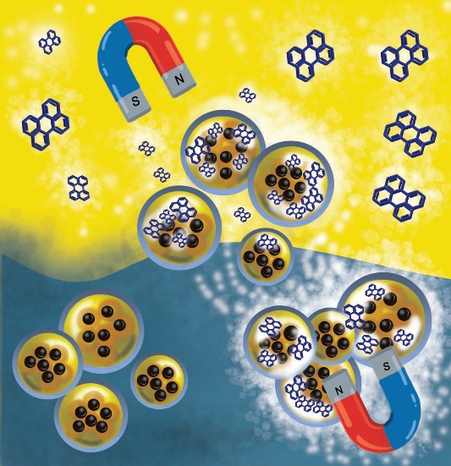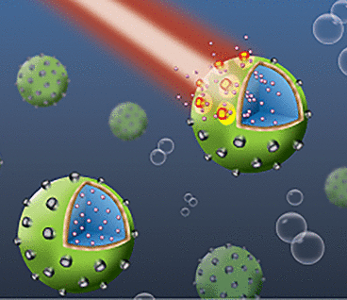
Fig. 1. Magnetically-navigated nanocapsules (left; J. Odrobińska et al. ACS Appl. Mater. Interfaces 2019, 11, 10905) and nearIR triggered release of the cargo from the polymer microcapsules (right; K. Chojnacka-Górka et al. ACS Appl. Mater. Interfaces 2021, 13, 1562)

This work was financed by the National Science Centre: grant Beethoven Classic 3
K/BTH/000009

